Team ID | PNT2022TMID09835
Project Name | Emerging Methods for Early Detection of Forest Fires
Team details | Team Leader: Praveen Kumar
 | Team member: Irfan A
 | Team member: P Ragul
Team member: R Naveenkumar
Team member: Dhanish Kumar

Data Flow Diagrams: A Data Flow Diagram (DFD) is a traditional visual representation of the information flows within a system. A neat and clear DFD can depict the right amount of the system requirement graphically. It shows how data enters and leaves the system, what changes the information, and where data is stored.

Example: FLOW

1.It is difficult to predict and detect Forest Fire in a sparsely populated forest area.

2.It is more difficult if the prediction is done using ground-based methods like Camera or Video-Based approach.

3.Satellites can be an important source of data prior to and also during the Fire due to its reliability and efficiency.

4.The various real-time forest fire detection and prediction approaches, with the goal of informing the local fire authorities.

5.If the fire is not detected ,it will send the result to the frame camera.if the forest fire will detected the alert will go to the video feed frame camera.
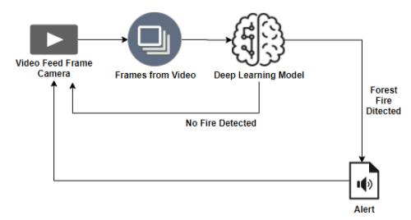

User Stories

Use the below template to list all the user stories for the product.

User Type | Functional | User | User Story I | Acceptance criteria | Priority | Release
 | Requirement | Story | Task
 |  | Number
Environme | Collect the | USER-1 | As an | It is necessary to | High | Sprint-1
nta list | data |  | Environmentalis | collect the right
 |  |  | t it is necessary | data else the
 |  |  | to collect data | prediction
 |  |  | of the forest | maybecome wrong.
 |  |  | which includes
 |  |  | the
 |  |  | temperature,hu
 |  |  | midity,wind and
 |  |  | rain of the
 |  |  | forest.
 |  | USER-2 | Identify | To collect the | Medium | Sprint-2
 |  |  | algorithms that | algorithm to identify
 |  |  | can be used for | the accuracy level of
 |  |  | prediction | each algorithms
 | Implement | USER-3 | Identify the | Accuracy of each | High | Sprint-2
 | Algorithm |  | accuracy of | algorithm-
 |  |  | each algorithms | calculated so that it
 |  |  |  | is easy to obtain the
 |  |  |  | most accurate
 |  |  |  | output
 |  | USER-4 | Evaluate the | Data is evaluated | Medium | Sprint-1
 |  |  | Dataset | before processing
 | Evaluate | USER-5 | Identify | These values are | High | Sprint-3
 | Accuracy of |  | accuracy,precisi | important for
 | Algorithm |  | on,recall of | obtaining the riaht
 |  |  | each algorithms | output
 | Display | USER-6 | Outputs from | It is highly used to | High | Sprint-4
 | Results |  | each algorithm | predict the effect
 |  |  | are obtained | and to High Sprint-4
 |  |  |  | take precautionary
 |  |  |  | measures

